<https://drive.google.com/file/d/1bOGjbEQlcbPycsgJh48fO6wkjRzHUygi/view>

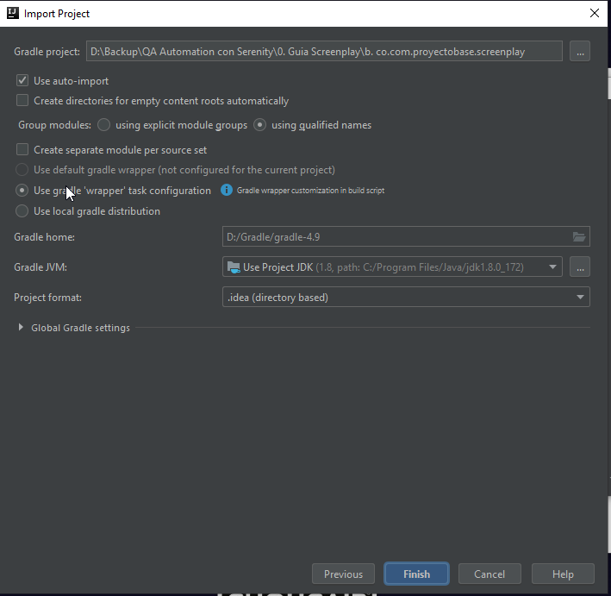

Ejecución por linea de comando:

gradle -Dtest.single=RunnerTags test aggregate

Serenity WAITS

<https://serenity-bdd.github.io/theserenitybook/latest/screenplay-selenium-tasks.html>